Project Completion Phase

Project Completion Summary
The Project Completion Phase marks the successful conclusion of the Motor Temperature Prediction Using Machine Learning project. This phase ensures that all planned activities have been completed, objectives have been met, and deliverables are finalized and validated. The project was executed following a structured development approach, progressing through ideation, requirement analysis, design, planning, implementation, testing, and documentation.

1. Achievement of Project Objectives
The primary objectives defined during the project planning phase were successfully achieved:
- A machine learning–based system was developed to predict motor temperature using operational and environmental parameters
- The system enables early detection of potential overheating conditions
- Predictive insights support preventive maintenance strategies
- The solution reduces unexpected motor failures and operational downtime
The project effectively transitions motor monitoring from a reactive approach to a predictive and data-driven model.

2. Completion of Planned Phases
All project phases were completed as planned:
- Ideation Phase: Identified the core problem, user needs, and project scope
- Requirement Analysis Phase: Defined system requirements, data flow, customer journey, and technology stack
- Project Design Phase: Established problem–solution fit, proposed solution, and system architecture
- Project Planning Phase: Created timelines, resource plans, risk management strategies, and milestones
- Implementation Phase: Developed data preprocessing pipelines and trained machine learning models
- Testing Phase: Performed functional and performance testing to validate system reliability
Each phase contributed systematically to the overall success of the project.

3. System Validation and Performance
The implemented system was evaluated using appropriate datasets and testing techniques:
- Functional testing confirmed that all system components operated as expected
- Performance testing demonstrated accurate and reliable motor temperature predictions
- The model showed consistency across varying input conditions
- Alerts were generated correctly when predicted temperatures exceeded safe thresholds
The system meets the defined functional and non-functional requirements.
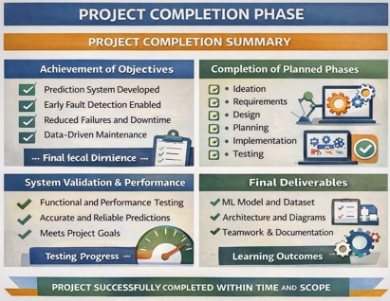

4. Final Deliverables
The following deliverables were successfully completed and submitted:
- Machine learning model for motor temperature prediction
- Clean and processed dataset
- System architecture and data flow diagrams
- Project documentation and technical report
- Presentation material for review and evaluation

5. Learning Outcomes
The project provided valuable technical and professional learning experiences:
- Practical understanding of machine learning algorithms
- Experience in data preprocessing and feature engineering
- Exposure to predictive maintenance concepts
- Improved teamwork, documentation, and project management skills

6. Limitations and Future Enhancements
Although the project achieved its objectives, certain limitations were identified:
- Dependency on the quality and availability of sensor data
- Limited real-time deployment in an industrial environment
Future enhancements may include:
- Integration with real-time IoT sensor networks
- Use of advanced deep learning models
- Cloud-based deployment and scalability
- Integration with industrial monitoring systems

7. Overall Project Outcome
The Motor Temperature Prediction project was completed successfully within the planned timeline and scope. The final system is reliable, scalable, and aligned with industrial predictive maintenance requirements. This project demonstrates the effective application of machine learning techniques to solve real-world engineering problems and lays a strong foundation for future enhancements and real-world deployment.

